Profiling SEMH needs 

A guide to tools that can be used to profile a child’s SEMH needs. For further information or support with these tools please book a consultation with a member of the North Ashfield Partnership team.
Observation – narrative  (long observation) | - an extended account of a period giving more specific details of a child's actions or speech during an activity, including specific quotes.  - between 20 and 30 minutes is ideal  - allow adult to record interactions, behaviours, spoken comments and reflect on the child in that environment
Observation – ABC | - Record what happened (Behaviour) • Record what happened before (Antecedent) • Record what happened afterwards (Consequence)  - Useful to understand behaviours and incidents  - A tool for developing behaviour support plans  - SBAP have ABC documents that can be shared with schools – please request by contacting a member of the team
Observation – time sampled | - 25 minute period with a recorded response every 15 seconds gives 100 responses (allows percentages of time on task, out of seat, distracting other etc to be evidenced)  - SBAP have a document for schools to use for time sampled observations – please request by contacting a member of the team
Sensory Profiles | - There are different types and versions available to schools e.g. C& I team sensory profile, Early Years sensory profile  - Ask SBAP team for examples as needed
Leuven Scale for Emotional Well-Being & Involvement | - There are 5 points to the Leuven scale for emotional well-being, and involvement scale with the first being used for an extremely low state of emotional well-being, and point five being used as the optimum emotional well-being a child can experience.  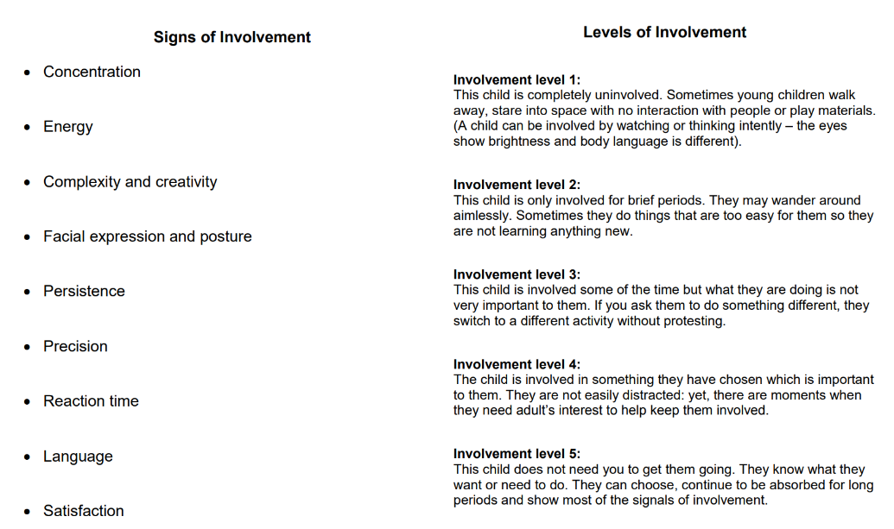  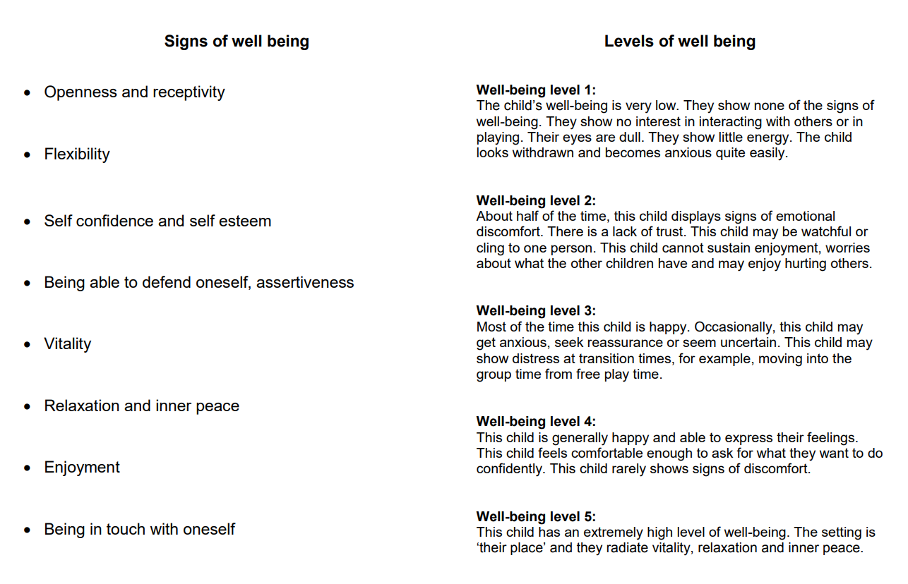
SDQ  Strength & Difficulties Questionnaire  (sometimes referred to as Goodman’s Questionnaire) | - a brief behavioural screening questionnaire for 2-17 year olds.  - several versions to meet the needs of researchers, clinicians and educationalists.  - Free to download https://www.sdqinfo.org/  - Available in 88 languages  - Used by different professionals so recognised and understood across agencies  - Identifies whether a child has internalising needs or externalising needs which then informs whether a talking or therapeutic type of intervention would support  - NAP request that schools complete an SDQ to ensure the correct type of support and intervention is offered  - Training / support to complete and interpret an SDQ can be requested from NAP.  - Request support from NAP to identify which strategies /interventions your school uses and whether they are externalising/internalising so an intervention grid can be completed to work alongside SDQ profiles  - Useful as an entry and exit profile at the start and end of interventions
ADHD observation | - A document that is part of the ADHD Toolkit and supports observation of children who may have or have a diagnosis of ADHD
SBAP SEMH observation form | - Tool to identify areas of strength and areas to focus support for a child in a classroom environment and the impact of strategies being used by the adults (see below)
Boxall Profile | - Assessment tool developed by Marjorie Boxall for use in nurture groups with children with complex SEMH needs  - Strongly linked to nurture provision and ethos  - Recognised mostly within education  - Identifies difficulties and strengths that link to learning behaviours – developmental strand shows positive learning behaviours (organisational skills & internalisation of control) and diagnostic strand shows needs/difficulties (behaviours that interfere with engagement in a classroom)  - NAP advise use of Boxall for children who access nurture provision  - Online version or paper version Boxall (boxallprofile.org)  - Cost – scaled depending on number of uses  - Beyond The Boxall – resources to identify strategies once Boxall is completed. There is also a Beyond the Boxall – Whole Class Strategies  - Training /support to complete and interpret a Boxall Profile can be requested from NAP.
Motional | - Measures mental health and wellbeing  - Linked to current neuroscience, understanding of trauma and ACES  - based on research on emotional systems in the brain & research around executive functional skills - mental skills that include working memory, flexible thinking, and self-control (Panksepp, Hughes, Siegel, Porges, Wells).  - online tool Motional – Mental Health and Wellbeing Online  - individual snapshots for individual children – can then contribute to group snapshots (small group/class/cohort) snapshots  - allows tracking over time  - provides adult with theory and their role in support a child  - provides strategies /interventions  - interactive platform that encourages users to contribute ideas /additional strategies  - cost – scaled depending on number of uses  - NAP subscribe to Motional to complete assessments for children. Some SAP schools and families of schools subscribe so schools ned to check how to access  - Training /support to complete and interpret a Motional assessment can be requested from NAP.
BRIEF assessment  (Behaviour Rated Index of Executive Functioning) | - The BRIEF2 assesses executive function in children  - intended to provide a standardised method of assessing executive functions in daily life. It is not disorder-specific so can be used to assess executive function behaviours in children experiencing a wide range of difficulties – learning behaviours, attention, brain injuries, autism , ADHD  - identifies which executive functions a child may have difficulties with  - used in some parts of UK to help identify ADHD  - supplementary ADHD form uses BRIEF2 scores and classification statistics within an evidence-based approach to predict likelihood of ADHD and determine subtype  - online version or paper – limited list of professionals that can purchase and use  - SBAP purchase BRIEF to assess children where ADHD / executive functioning is a concern to identify need and support planning  - discuss whether BRIEF would be suitable as part of a consultation/case work discussion



