
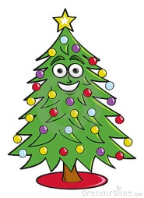
Surviving Christmas

For children who find it hard to cope
Consider: What could I do to help?
Is Christmas a positive memory / experience? Are there issues you need to be mindful of?
What will happen at Christmas? What traditions / events will take place at home? Where? Who with? What will be happening at school? What will be hard?
Does your child know what will happen in school and at home? Do not assume that children will remember each year – take time to explain. Would photos/a diary / calendar help?
How will the environment change in school and at home? Consider classroom/hall/living room/ bedroom other spaces?
How will routines change? Consider everyday routines e.g. opening advent calendars/school post box/ rehearsals/ timetable changes etc
Will availability of school staff change at all on specific days? When? Does the child know in advance? What are the plans needed to manage this?
If children are involved in ‘special’ activities or jobs can they cope with this e.g. handing out Christmas cards/ parts in the play
How can we support this?
When planning special events consider which parts will this child enjoy / dislike?
How do we make it a success? Which bits might be tricky?
What is the ‘emergency’ plan? Where will they sit? Who with? What distraction / strategies can adults use?
Are they getting enough sleep / relaxation/ calm time at home? School? Do we need to increase ‘down time’ for a few weeks?
What arrangements / plans do you need for special trips? (Panto, church etc )
Is there a calm ‘Christmas free zone’ for children (or parents ) to access?
What sensory sensitivity issues might need to be considered?
A few of the sensory experiences that may need to be considered:
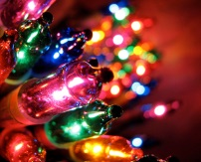
- Lights/tinsel on trees
- Smell of trees
- Hanging decorations/ paper chains
- Noise of rehearsals (more singing at Christmas than any other time of year!)
- Sitting for periods of time in rehearsals – comfort, closeness to others
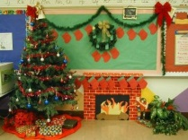
- Change in appearance of environment / furniture moving
can be visually distracting
- Smell of Christmas dinner
- Wearing a costume
- Noise of party music and excited children
- Santa!!
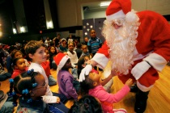
- Crackers, crackly party hats
- Discos – noise, heat, closeness of other people
- Party games

