
North Ashfield Partnership NEWS

Welcome to the Autumn term!

Useful contacts

Early Help Unit: 0115 804 1248
MASH consultation line: 0300 500 80 90
Healthy families advice line: 0300 123 5436
Neurodevelopmental support team:
Enquires: familyservicenbs@nottscc.gov.uk
referrals: referralsnbs.familyservice@nottscc.gov.uk
Check where your pupil is on the waiting list and update them on any changes in behaviour- especially risk of suspension or permanent exclusion
**Remember to keep your e-mail chain when sending in GTKM forms as proof of submission.
Nott alone website: Mental Health Support Services For People In Nottinghamshire | NottAlone
Notts help yourself: Nottshelpyourself

NAP team contact details-

Lucie Keeling Specialist teacher

07789944232

lucie.keeling@nottscc.gov.uk

Sam Hovell Specialist Children’s Worker

07974842899

samantha.hovell@nottscc.gov.uk

North Ashfield Partnership surgeries – are so popular and when used as part of your graduated response they provide an additional point of view to a case. Surgeries are based on a solution circle approach with a 45-minute time slot on TEAMS. The days and times vary and there are after school times available.

The panel includes Lucie and Sam but invitations also extend to the District SENCo and the Family SENCo for each family of schools who attend if they can.

Let us know if you want to observe the panel as part of your CPD.
Please ensure you have completed the parental permission.
Dates for the year:

Autumn term dates: 15/9/25, 2/10/25, 13/10/25, 6/11/25, 17/11/25, 4/12/25, 15/12/25

Spring term dates: 12/1/26, 28/1/26, 12/2/26, 5/3/26, 18/3/26,

Summer term dates: 30/4/26, 20/5/26, 8/6/26, 24/6/26, 29/6/26, 15/7/26

TEAMS, Face to Face or email? Look out for these logos:




Attached groups:
The first session will always be a parent only one in order to discuss their concerns and set out ground rules and expectations. Parental attendance secures the place.
Please email Lucie for details or to book a place.

Group | Term | What is it? | Where and when is it?
  Mindful Bods | Autumn | Mindful Bods: These are ‘Attached’ sessions with parents and children and focus of developing a calming, ‘wind down’ routine that can be replicated at home. | TBC  .  
Forest Schools | All year | Forest Schools: These have been so successful, really allowing families to work on their relationships in a different environment! | St Andrew’s School, Skegby  Wednesday mornings 10 until 11  

Check out our website:
North Ashfield Partnership - Home

The North Ashfield Partnership operates within a problem-solving graduated response
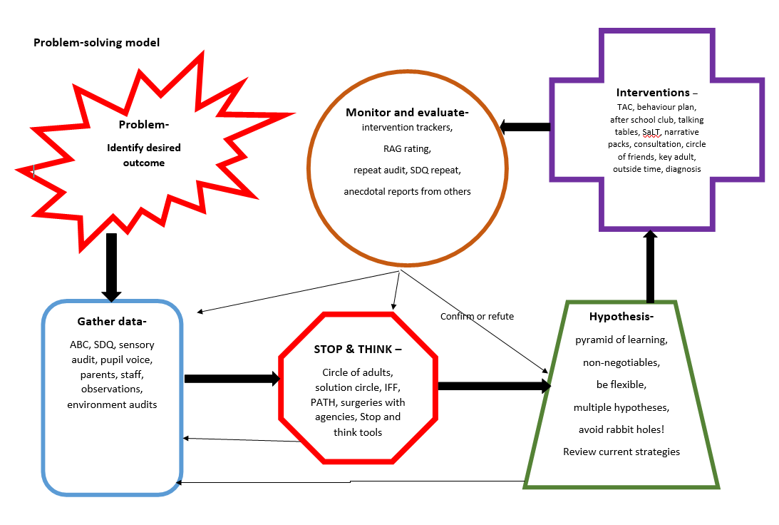
What is it? | When ? | Where? | Paperwork?
  NAP surgery panel (NAP, district SENco, Family SENco): Solution focused meeting to raise concerns and offer advice on next steps. Permissions allow the recording of the advice onto the child’s Mosaic page thereby following a gradated response. | Dates on page 1 | TEAMS | Surgery permissions returned to Lucie Keeling
  Graduated response workshop- This workshop supports the development of a clear graduated response in your school. | 27/2/25 |   TBC | None needed  Email Lucie to book a place
High profile pupil meeting. This meeting serves as a graduated response and monitoring of need within the school population. Progress is tracked and discussion focus on problem solving | Termly | In school | Lucie holds the notes and shares them with school.  Contact Lucie to book an appointment
TA support clinics  A safe space for support staff to offload, seek advice or learn about different stratergies or training opportunities. | All year | After-school time slots available | Contact Sam Hovell to book
TA NETWORK | Each term | Face to face | Family Sencos send out dates
Teacher support clinics  A safe space for teachers to offload, seek advice or learn about different stratergies or training opportunities. | All year | After-school time slots available | Contact Lucie to book
Graduated response to SEMH needs This approach supports the tracking of prosivion and support put in place. | Complex cases | Emailed document | Sent out to schools

Training/ CPD - The NAP surgery can always be observed – contact Lucie Keeling

What? | Where? | When?
  Solihull Foundation training Develop an understanding of the Solihull Parenting Approach and support parents in your own school- no waiting for referrals. | Venue TBC   | Autumn and Spring terms – Contact Lucie Keeling to book a place
Solihull parenting group training: run the parent group in your own school, no waiting for referrals |   Venue TBC | Summer term- contact Lucie Keeling to book a place
Solihull supervision sessions: time for Solihull practitioners to explore any tricky situations and received supervision outside of the school environment | Venue- To be agrred or | Contact Lucie to book a place
  Escalation Scale workshop  Develop your skills when unpicking challenging behaviours. A workshop to create a scale making clear, not only the behaviours and what to do in response but who to contact. | Venue TBC   | Contact Lucie to book a place
  Emotional Literacy Footprint Workshops  Have a go at a few of the activities and receive the planning so you can run them in your own school, to enhance your ELSA groups or as standalone ELF interventions. | Venue TBC   | As requested and set dates – contact Sam Hovell for details

EMOTIONAL LITERACY FOOTPRINT SESSIONS:
- Emotions through art - Any age This programme is designed to explore different emotions through art. This is a 6-week program, the children will learn 6 different art styles, learning new techniques to express their emotions and develop new vocabulary whilst exploring different artists.


- Emotion potion - Any age Each session will explore different emotions to enable the children to understand how their emotions affect their bodies, giving them a better understanding of how to deal with strong emotions. It could get a little messy, as slime making is just one of the experiments we will do!

- Queen Bees –KS2 children will learn about different types of relational aggression, explore different roles that can be taken on in a group and the advantages and disadvantages of each role.

- Eggspressions –Any age -children bake 6 different recipes, each recipe relates to a different ‘Eggspression’. In each session the children discuss their feelings connected to the Eggspression of the day.



- Inside out – Any age - sessions where children learn about their emotions and explore each of the emotions from the film ‘Inside Out’.


- Nursery rhyme emotions- FS -In each session the children sing about the nursery rhyme and talk about the feelings connected to the song.


- Mr Men – explore emotions through the stories of the Mr Men

Exploring needs – the NAP can support schools to develop a picture of a pupil’s needs

What? | How can it help? | Who can support?
Motional is a social, emotional, mental health screening tool used to help identify the child’s main needs in the seeking systems in the brain and their affect on the executive functioning of the child.   | The tool presents a menu of possible interventions to follow on and the report it produces are helpful in supporting reports or funding bids. | NAP team  If your family of schools doesn't buy into Motional, the NAP does, so let us know if you would like this assessment for one of your children.
Strengths and difficulties questionnaire.  Identifies whether a child has internalising needs or externalising needs which then informs whether a talking or therapeutic type of intervention would support | The impact score serves as support for a child accessing interventions outside of their classroom | NAP team can support the completion of the tool, train staff and support the development of your own school’s interventions following the use of the tool.
Observations can be narrative, ABC, time sampled or ADHD trait-focussed | Observations can be completed to give an additional snapshot of a child, look at interactions and communicating styles | Lucie or Sam in school
Sensory checklists can support the development of provision around any unmet sensory need | Checklists can support the exploration of unmet need and provide information for provision | NAP team at school and in the home
Solihull ages and stages of emotional development | This supports the exploration of the emotional age of a child in order to plan provision and approaches that best suit them. | NAP team at school and in the home  Trained school staff can complete this on their own
Leuven’s scales gather information about the involvement a child has in an activity and describes their emotional well-being | The scaling supports understanding of the interaction levels of the child | NAP team at school and in the home  School staff can complete this on their own

